Online Camper Registration Help Guide

All registrations for summer camp are now being collected online. Online registration is the best way for us to keep track of all camper information and for families to adjust their camper’s accounts if needed. If you have any questions or need more assistance, please call Butler Springs at (937) 588-2205 or email camp at info@butlersprings.com. We are happy to help!
Create New Account/Login
These are family accounts, so you can add more than one camper to each account. We suggest that the parent/guardian signing campers up creates the account under their own name then adds campers to the account. Campers can be added years after original family account has been made.
- If you have already have an account with Butler Springs (this includes accounts created to register campers, donate, volunteer, etc.), please do not create a new one, just login. You can login with your existing login information.
  - If you forgot your login information, please contact Butler Springs and we can help you get into your account. Please do not create a new account!
- If you do not have an account, create a new one.
  - Creating a new account will prompt you to fill out personal info and answer security questions.

Adding Campers to an Existing Account
- If logging into an existing account, and you need to add a camper whose name does not appear on your list, click the green “Add Camper” button.
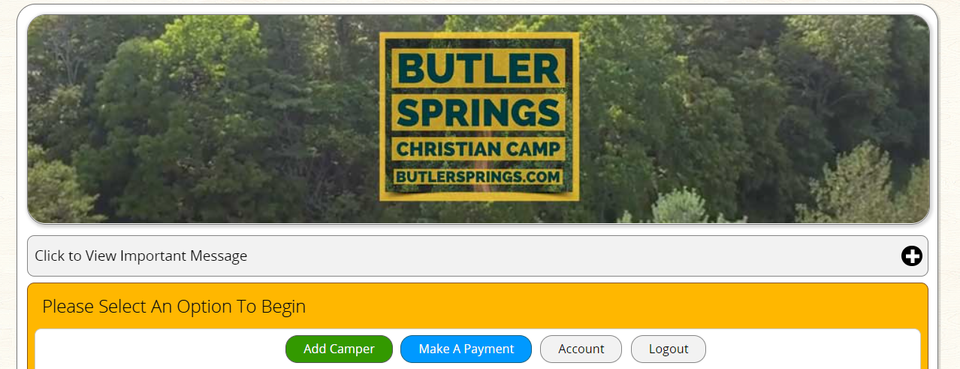

- A popup will then appear, select “Add New Camper”.

- You will then be given options as to how you want to create the camper in the system. New campers can be created using existing camper information (to save from reentering information), all new information, or you can turn someone on your account who is not a camper (parents/guardian/ emergency contacts) into campers.
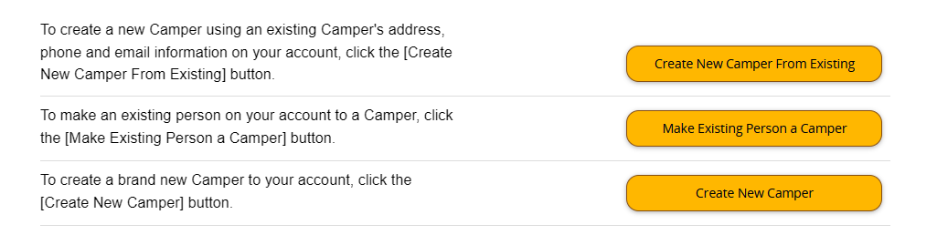
- After making this selection, fill out all following information.

Adding a Camper to a Session
- Select “Register (New)” for the camper being registered to a NEW camp session.
  - “Update Info” will allow you to change existing information for a camper.

- All the camp sessions that camper is eligible and are not full for will appear here for you to choose from. Select the camp your camper wants to attend.

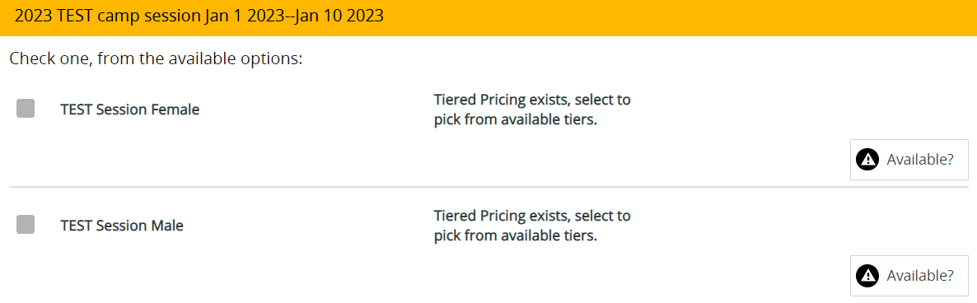

- The following popup will appear. Select the price you will pay for camp. There is no pressure to pay for more than the typical rate. This is just a way for those who have asked and feel lead to give back to camp.
- Save/Next.
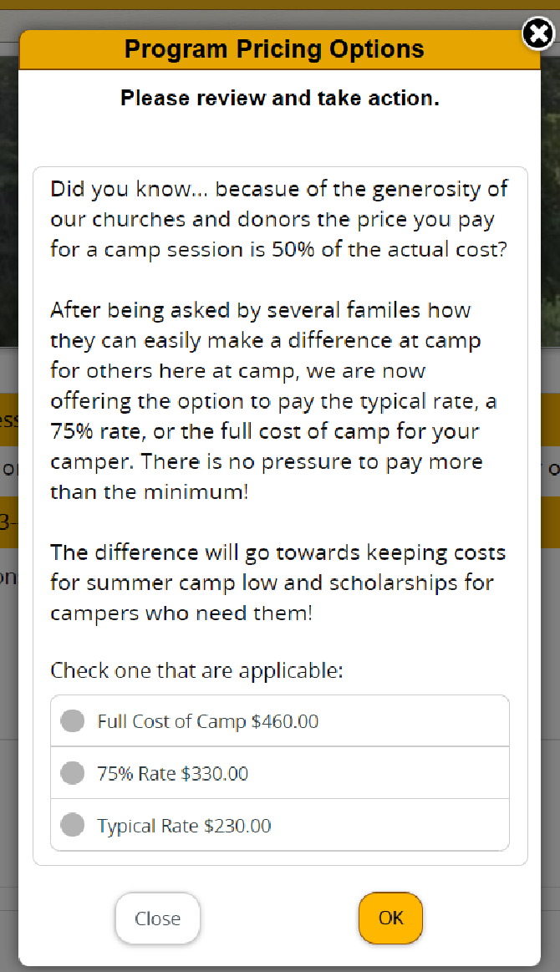

Select/Update Contact Information
- New contact information can be added by selecting “Add New Contact”.
- If you already have contacts associated in you account, they will appear in the drop downs. You can also edit contact information from this page.
- Save/Next

Forms
All forms, waivers, and camper information need to be completed online and before arriving to camp. These forms are important, so please make sure all forms that appear are completed before moving on.
- Click the “Open” button to see form.
- Fill out all required information, click “Save/Next” to return to the forms page.
- When all forms are completed, they will say “Form completed or no items on form are required. Ok for next step.” in green, click the Save/Next button.

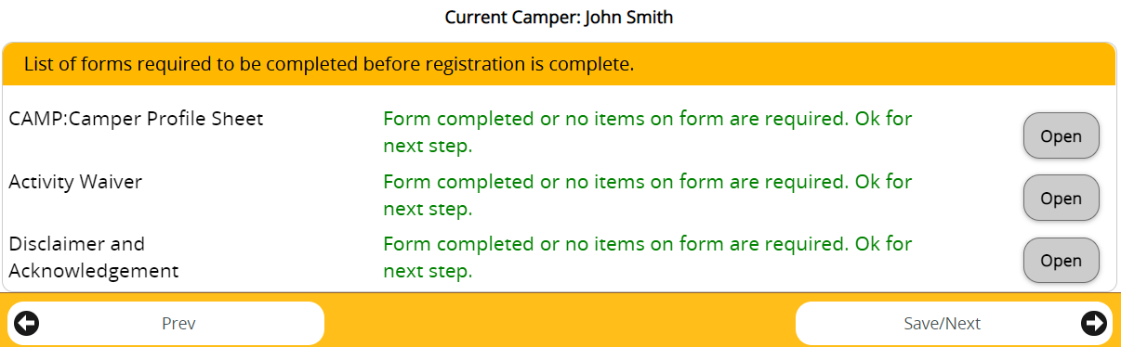

Medical Information
Camper medical information is extremely important. Please make sure all information is up to date when arriving at camp. Information given now can be updated prior to check-in. If you have any questions, please contact camp.
Prescription/Daily Medication
While at camp, the First-Aid Person (FAP) will oversee administration of camper medication. ALL MEDICATION THAT A CAMPER BRINGS WITH THEM TO CAMP MUST BE CHECKED IN, PERSCRIPTION OR OTHERWISE. All information for the medication needs to be reported to us before check-in. (This includes allergy medications and as needed medications.)
- If camper is bringing medication with them to camp, select “Yes” from the dropdown menu. If not, select “No”.
- If “Yes”, enter quantity, or number of medications camper will be checking in. If “No” you are now done with prescription meds, check out the OTC section of the help guide.
- Then select “Add/Edit Meds”

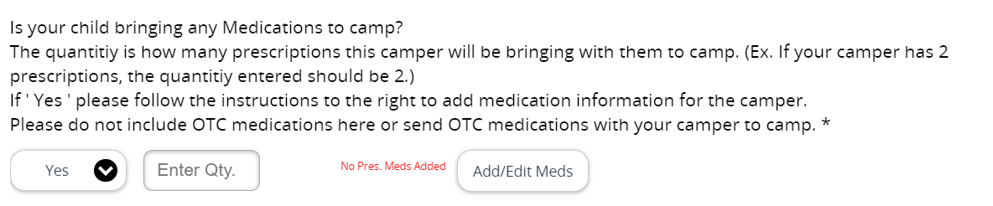
- Fill out the required information, then click “Select Sessions”, this allows you to attach the medication to your camper’s session. If they are signed up for more than one session, you can attach the medication to both at the same time.
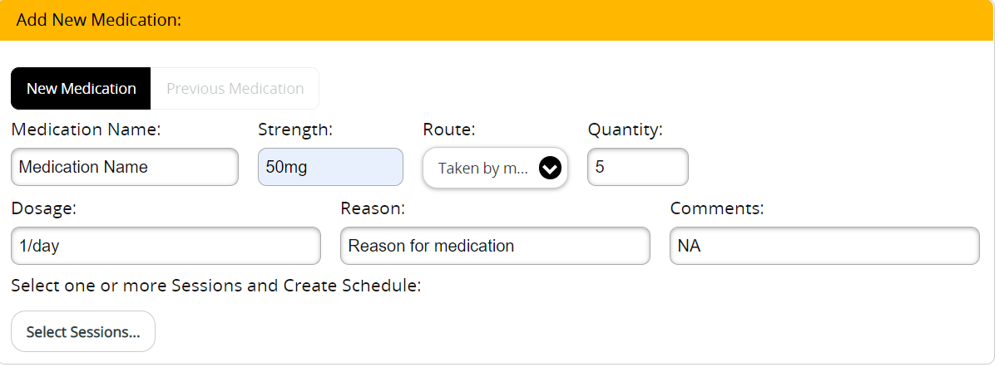

- Once you select your camper’s session, you click “Create Schedule”

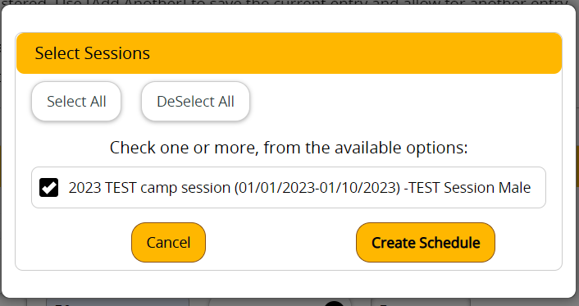

- The below timetable will appear.
- Checkmark the times your camper needs to take their medication(s) for each day they will be at camp.
- This will create a checklist for the Fist Aid Person to make certain all campers have received their medications.
- You will be asked to do this for each medication you are checking in with your camper.
  - This information will be double-checked at the time of camp check in where the FAP will have access to this information and parents and campers can confirm information with them.

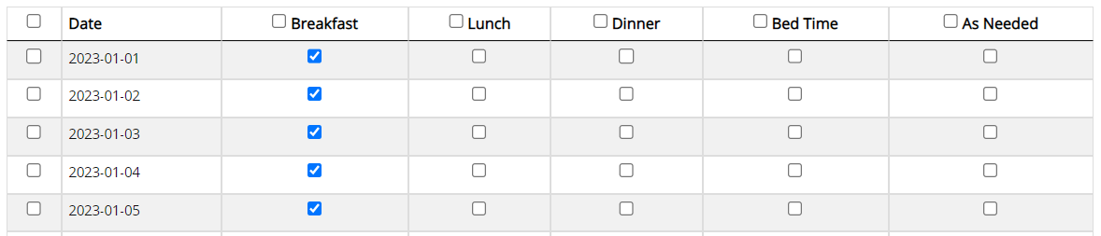
- Click “Save/Next”

Over the Counter Medication
- Even if we cannot give your camper OTC medications at camp, the only option in the dropdown is “Yes”, make sure it is selected.
  - This is hard written into the software; we cannot change it.
- Click “Add/Edit OTC” to let us know what they can/cannot take.
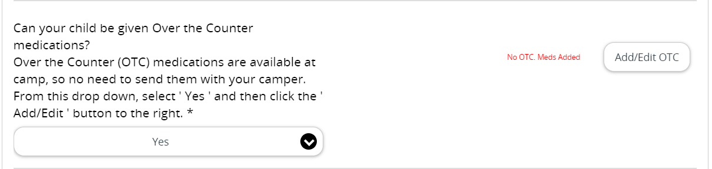

- A list of medications will appear, select the ones that are allowed to be given at camp, if none, select “None of them”
- “Save/Next”
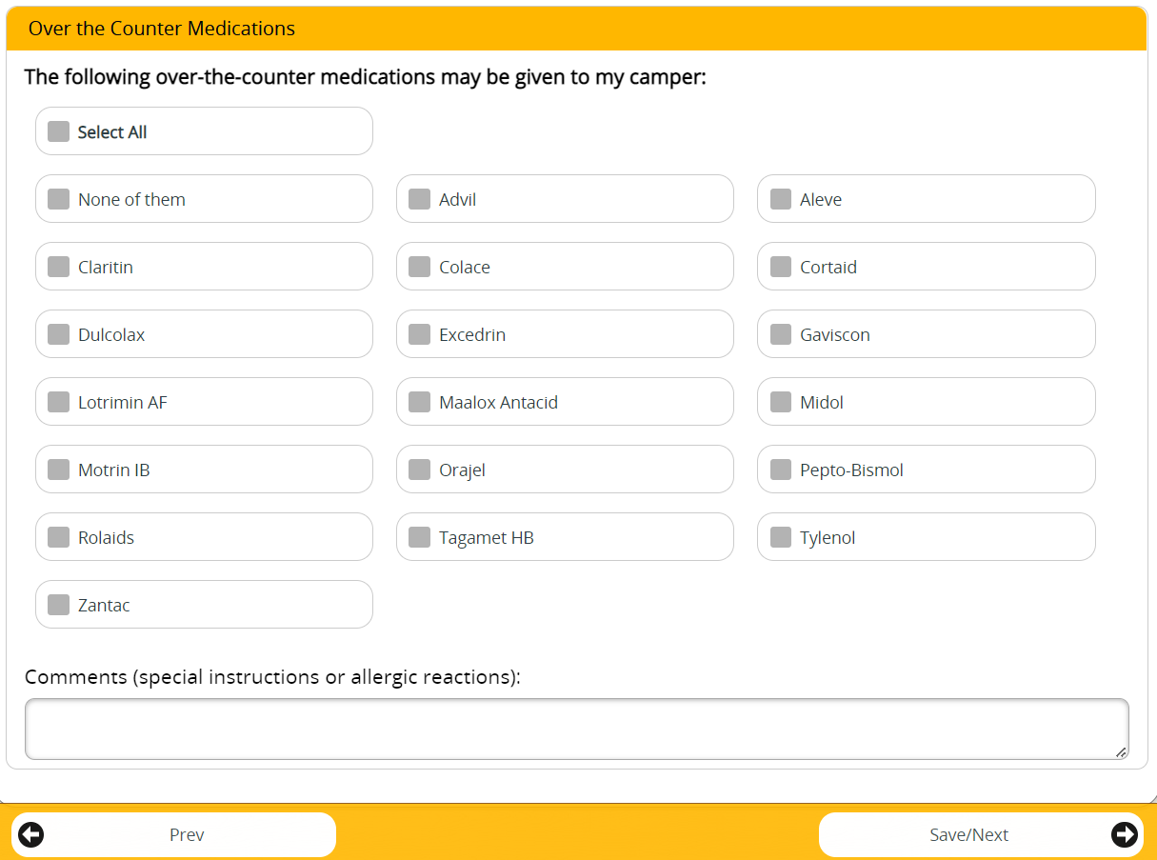

Allergies
- Even if your camper does not have allergies, the only option in the dropdown is “Yes”. Make sure it is selected
  - This is hard written into the software; we cannot change it.
- Click “Add/Edit Allergy” to let us know about your camper’s allergies.
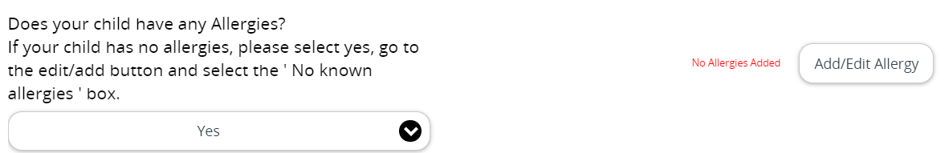

- This page is where you will enter any allergy information.
- “Save/Next”
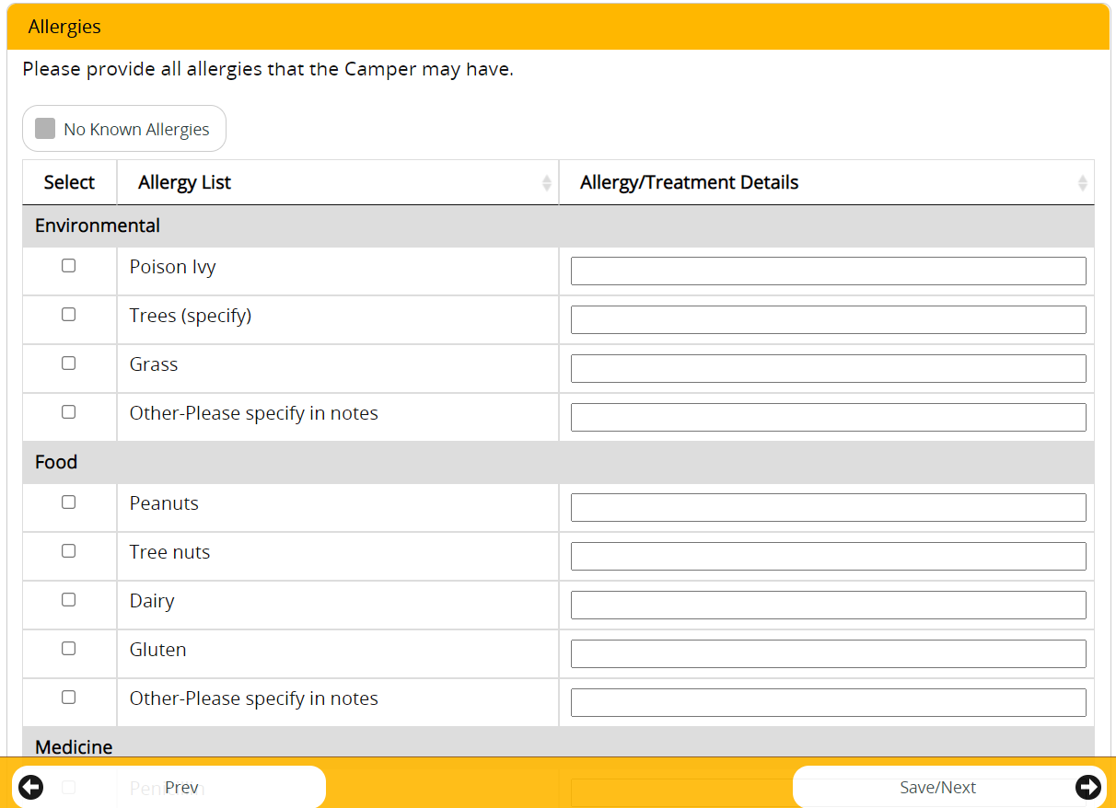

Payments
Coupon/Discount Codes
- Coupon codes: if you have one, it will be given to you by your church. Churches are responsible for getting a code setup with camp and giving it to families.
- Once you enter your code, the corresponding amount will be deducted from your camper’s balance dues.
- If you have any questions about a discount, please contact camp.
- “Save/Next”
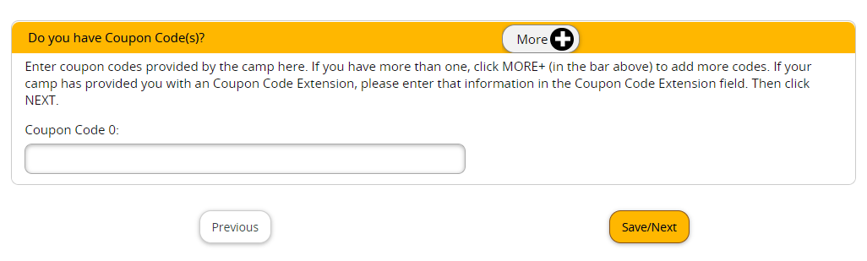
Make Payment Page
There are several things you can do from this page, Make a registration payment, make a donation and put money on your camper’s store account for them to spend while at camp. If you have any questions, please contact camp.
- Select campers you are making payments for. If you have more than one camper registered under our account, you can select the campers you would like to make payments for at one time.

Registration tab
From the registration tab you can donate to BSCC if desired and make registration payments.
- Donation payments are NOT the same as a registration payment. Please make sure you do not put in an amount here thinking it is for registration.
- Your donation will be added to your total at the end. You will receive a specific donation receipt at the end of the month for your donation.
- If you do not want to make a donation, leave the amount as $0.00.

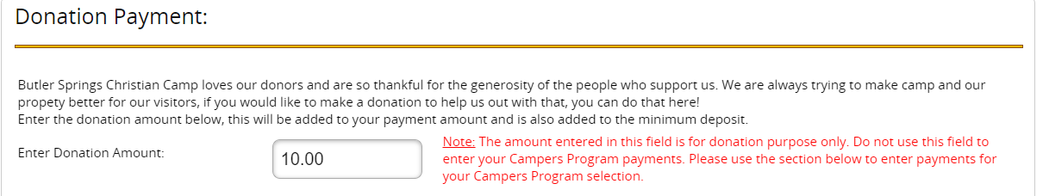
- You can make the minimum deposit, full payment, or other payment. Select the amount you would like to pay at this time.
- Save/Next

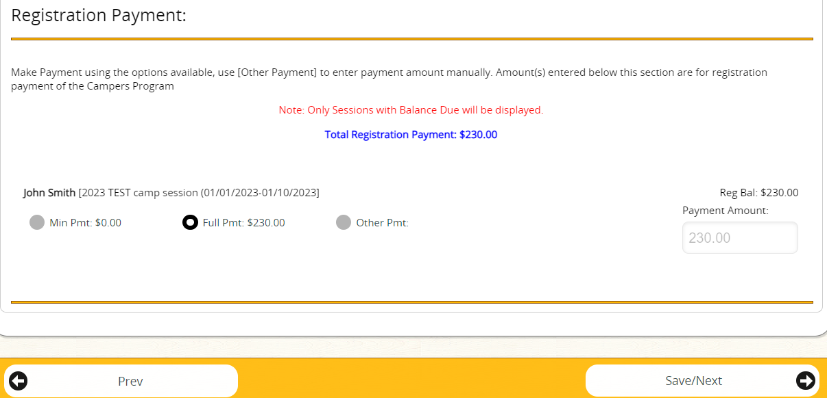

Camp Store tab
From this tab, you can add money to your camper’s store account. This will allow them to buy things while at camp without leaving any cash with them. We will be able to track how much money each camper has to spend through out the week.
- Enter amount you would like to leave for the camper. Amount will be added to you total at check out.
- If none, leave as $0.00
- There will be no refunds on money not spent at canteen. Money not spent at canteen will go toward the summer mission.
- Save/Next
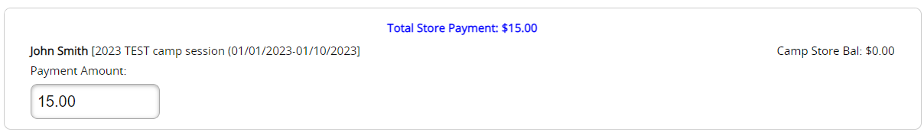

Payment Option tab
This is where you will check out and make payments for your camper’s session.
- Your total for registration, donation, and camp store will appear here.
- You can pay with credit card (we do NOT accept American Express) or mail in a check. We prefer credit card payments. Please DO NOT mail cash into camp.
- Enter payment information.
- Save/Next
- After payment is made, you should have a completed camper registration!
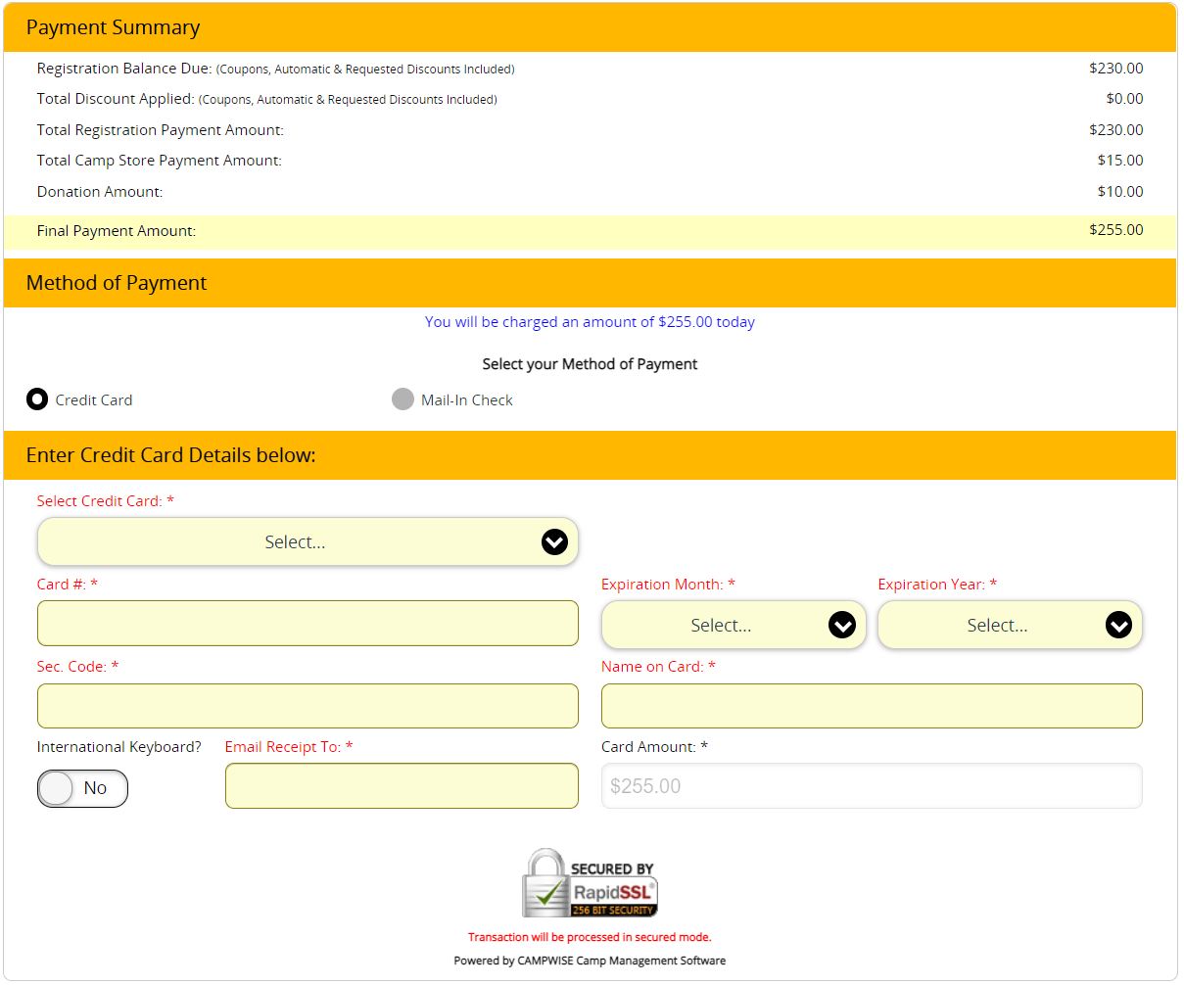

You can log back into your account to make payments, update medical information, camper information, emergency contact information, or add a new camp session.

Once again, if you have any questions or concerns, please contact camp, we are more than happy to help!
(937)588-2205
info@butlersprings.com

